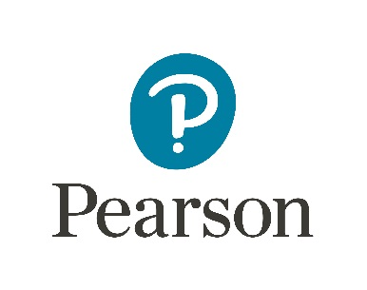
Exercise – Level 2 Supply Chain Warehouse Operative

Name of Applicant:

Instructions:

As part of your application for this role, we would like you to submit two short answer questions. These should be written for the following

Details:
The following is taken from the Level 2 Supply Chain Warehouse Operative Apprenticeship Standard:

Knowledge to be assessed:
Describe how to use warehouse systems and processes relating to packaging, moving and receiving stock.

(Please provide 2 sample questions based on this criteria; questions should be 1 or 2 mark, short answer, open response questions; please include your mark scheme.)

